The Influence Of Product And Service Quality On Customer Satisfaction At Tirta Jeneberang Regional Water Company (Pdam) In Gowa Regency

Rahmat Herman¹⁾, Buyung Romadhoni²⁾, Sherry Adelia Natsir Kalla³⁾
^{1,2,3)}Management Study Program, Faculty of Economics and Business, Universitas Muhammadiyah
Makassar, Indonesia

*Coresponding Author
e-mail : ¹rahmatherman59@gmail.com,
²buyung@unismuh.ac.id , ³ sherryadelia@unismuh.ac.id ,
Abstract
This research is a quantitative descriptive study aimed at understanding and analyzing the Influence of Product and Service Quality on Customer Satisfaction at the Tirta Jeneberang Regional Water Company (PDAM) in Gowa Regency. The methods used in the research include observation, questionnaires, and documentation. The population and sample used in this study consist of 94 respondents, with data analysis performed using multiple linear regression analysis processed with the aid of Statistical Product and Service Solutions (SPSS) Version 27 software. Based on the results of this study, the t-test results obtained for variable (X1) against variable (Y) show that the t-value is greater than the t-table value, with a calculated value of 4.396 > 0.202 and a significance value of 0.001, which is less than the alpha value of 0.05 (0.001 < 0.05). From these values, it can be concluded that variable (X1) has a positive and significant effect on variable (Y) at the Tirta Jeneberang Regional Water Company (PDAM) in Gowa Regency. Similarly, the t-test results for variable (X2) against variable (Y) show that the t-value is greater than the t-table value, with a calculated value of 9.723 > 0.202 and a significance value of 0.000, which is less than the alpha value of 0.05 (0.000 < 0.05). From these values, it can be concluded that variable (X2) has a positive and significant effect on variable (Y) at the Tirta Jeneberang Regional Water Company (PDAM) in Gowa Regency.

Keywords: Product Quality, Service Quality, Costumer Satisfaction

INTRODUCTION

Currently, we have access to information through specialized media provided by various companies, and we can also provide a platform for free expression. It is also important for companies to use this media to enhance relationships with their customers, which in turn improves the company's quality. Customer satisfaction is a direct and impersonal expression of one's preferences or disappointments after comparing a product or service with what they received and expected. As a result, the company's reputation becomes poor in the eyes of consumers, and those unfamiliar with the company are likely not to "stay" with it. Although this is very important, many companies find it very difficult to see and measure how dissatisfied, less satisfied, satisfied, or very satisfied their customers are with the products or services they offer.
A company that understands customer needs is always worthy of surviving in this industry. Conversely, if a company fails to anticipate the needs desired by customers, it will eventually lead to negative consequences, such as a decline in the company's image in the eyes of the public and the possibility of bankruptcy (Rangkuti, 2016). Customer satisfaction has always been a hot topic among marketers because it greatly determines the growth rate of a business. The issue is clear: if customers are not satisfied, they will switch to another company. The problem does not end there. Tjiptono & Diana (2018) state that if the quality of service products provided is below customer expectations, they will feel dissatisfied. However, if the quality of service products meets customer expectations, they will feel satisfied.
The Regional Drinking Water Company (PDAM) of Gowa Regency is a service company that provides clean water to the community and is directly managed by the Gowa Regional Government. In this management, the provision of an MIS (Management Information System) function is essential to improve the quality of effective and efficient service to all customers of PDAM Tirta Jeneberang in Gowa Regency. In the maintenance area, 285,766 people, or 48.05% of the total population of 594,681, received drinking water services in December 2019, while in the regency area, 37.57% of the total population of 760,607 received these services.

RESEARCH METHODS

In this study, the author employed a quantitative method utilizing and developing mathematical models, theories, or hypotheses related to natural phenomena. The research measurement process involved sampling from the population and using questionnaires as a data collection tool. The survey method design used in this research is quantitative descriptive.
This research falls under the category of quantitative descriptive research as it involves concept development and data collection to test the influence of product and service quality on customer satisfication at tirta jeneberang regional water companya (PDAM) in gowa regency. Data collection techniques in this study included observation, questionnaires, interviews, and documentation.
The data analysis method employed in this research utilized quantitative descriptive analysis, validity testing, reliability testing, classical assumption testing, multiple linear regression analysis, and hypothesis testing.

RESULTS AND DISCUSSION

- Respondent descriptive analysis
- Characteristics of respondents based on gender
The characteristics of respondents based on gender can be grouped into 2 types, namely men and women. For more details, they are presented in table form as follows
Table 1. Characteristics of respondents based on gender
No | Gender | Frequency | Frequency (%)
1 | Men | 56 | 59,6%
2 | Women | 38 | 40,4%
Total |  | 94 | 100%
Based on the data above, it can be concluded that the characteristics of respondents are based on gender, where male gender is at 56 respondents (59,6%), while female gender is at 38 respondents (40,4%).

- Characteristics of respondents based on age
Table 2. Characteristics of respondents based on age
No | Age | Frequency | Frequency (%)
1 | <30 | 15 | 16,0%
2 | 31-40 | 38 | 40,4%
3 | 41-50 | 26 | 27,7%
4 | 51-60 | 10 | 10,6%
5 | >60 | 5 | 5,3%
Total |  | 94 | 100(%)
Based on the table above, it can be concluded that respondents in the age range of 31-40 have the largest number, totaling 38 respondents with a percentage of 40.4%. Next, respondents in the age range of 41-50 total 26 respondents with a percentage of 27.7%. Respondents in the age range of less than 30 total 15 respondents with a percentage of 16.0%, and respondents in the age range of 51-60 total 10 respondents with a percentage of 10.6%. Finally, respondents in the age range of over 60 total only 5 respondents with a percentage of 5.3%.
- Characteristics of respondents based on educational level
Table 3. Characteristics of respondents based on educational level
No | Last Education | Frequency | Frequency (%)
1 | SD | 10 | 10,6%
2 | SLTP | 8 | 8,5%
3 | SLTA | 38 | 40,4%
4 | D3/S1 | 38 | 40,4%
Total |  | 94 | 100%
Based on the table above, it can be concluded that the last education level of respondents in the categories of Senior High School (SLTA) and Diploma/Bachelor's (D3/S1) is the same, with 38 respondents each, representing 40.4%. In the Elementary School (SD) category, there are 10 respondents, accounting for 10.6%, and in the Junior High School (SLTP) category, there are only 8 respondents, accounting for 8.5%.
- Data Quality Test
- Validity Test
Table 4.1 Validity Test of X1
No | Item | Validitas |  | Keterangan
No | Item | r_{hitung} | r_{tabel} | Keterangan
1. | X1.1 | 0,618 | 0,202 | Valid
2. | X1.2 | 0,608 | 0,202 | Valid
3. | X1.3 | 0,622 | 0,202 | Valid
4. | X1.4 | 0,747 | 0,202 | Valid
5. | X1.5 | 0,741 | 0,202 | Valid
6. | X1.6 | 0,567 | 0,202 | Valid
7. | X1.7 | 0,773 | 0,202 | Valid
8. | X1.8 | 0,734 | 0,202 | Valid
9. | X1.9 | 0,498 | 0,202 | Valid
10. | X1.10 | 0,499 | 0,202 | Valid
Source : SPSS V.27 Data Processing Results
Table 4.2 Validity Test of X2
No | Item | Validitas |  | Keterangan
No | Item | r_{hitung} | r_{tabel} | Keterangan
1. | X1.1 | 0,528 | 0,202 | Valid
2. | X1.2 | 0,310 | 0,202 | Valid
3. | X1.3 | 0,609 | 0,202 | Valid
4. | X1.4 | 0,610 | 0,202 | Valid
5. | X1.5 | 0,521 | 0,202 | Valid
6. | X1.6 | 0,721 | 0,202 | Valid
7. | X1.7 | 0,541 | 0,202 | Valid
8. | X1.8 | 0,588 | 0,202 | Valid
9. | X1.9 | 0,634 | 0,202 | Valid
10. | X1.10 | 0,706 | 0,202 | Valid
Source : SPSS V.27 Data Processing Results

Table 4.2 Validity Test of Y
No | Item | Validitas |  | Keterangan
No | Item | r_{hitung} | r_{tabel} | Keterangan
1. | X1.1 | 0,408 | 0,202 | Valid
2. | X1.2 | 0,533 | 0,202 | Valid
3. | X1.3 | 0,617 | 0,202 | Valid
4. | X1.4 | 0,595 | 0,202 | Valid
5. | X1.5 | 0,612 | 0,202 | Valid
6. | X1.6 | 0,471 | 0,202 | Valid
7. | X1.7 | 0,765 | 0,202 | Valid
8. | X1.8 | 0,613 | 0,202 | Valid
9. | X1.9 | 0,765 | 0,202 | Valid
Source : SPSS V.27 Data Processing Results
Based on the table above, researchers obtained results from all statement items in the questionnaire that is, the rcount value is greater than the rtable value, namely 0.202. The researcher concluded that all statement items in the questionnaire could be said to be valid.
- Reliability Test
Table 5. Reliability Test
No | Variable | Total Item | Cronbach’s  Alpha | Standard  Value | Information
1. | Product Quality | 10 | 0,839 | 0,60 | Reliable
2. | Service Quality | 10 | 0,773 | 0,60 | Reliable
3. | Customer Sastifaction | 9 | 0,775 | 0,60 | Reliable
Source : SPSS V.27 Data Processing Results
Based on the table above, from the results of the reliability test obtained by the researcher, it can be concluded that all question items for each variable are declared reliable, with Cronbach's alpha values of 0.839 for variable X1, 0.773 for variable X2, and 0.775 for variable Y. These values are greater than the standard reliability testing value of 0.60.
- Classic Assumption Test
- Normality Test
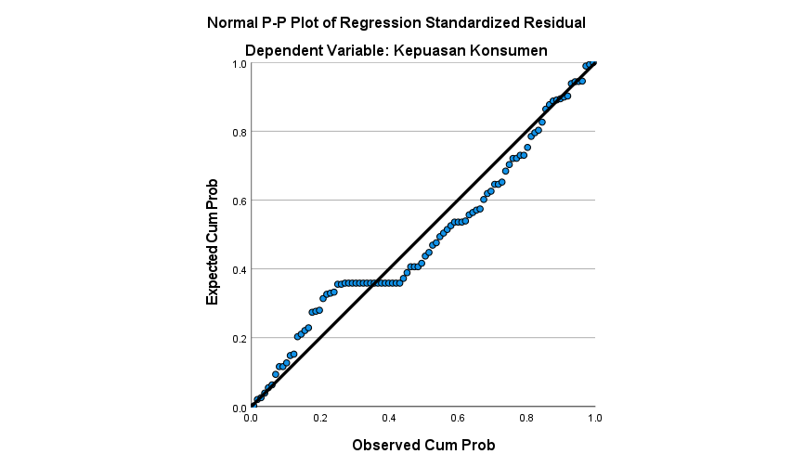
Figure 1. Normality test
Source : SPSS V.27 Data Processing Results
Based on figure above, it can be seen that the distribution of data in this study follows the normality line so that it can be concluded that the data processed is normally distributed data.

- Multicollinearity Test
Table 6. Multicollinearity Test
Coefficientsª
Model |  | Unstandardized Coefficients |  | Standardized Coefficients | t | Sig. | Collinearity Statistics
 |  | B | Std. Error | Beta | t | Sig. | Tolerance | VIF
1 | (Constant) | 7.311 | 3.018 |  | 2.422 | .017
1 | Kualitas Produk | .449 | .084 | .468 | 5.326 | .000 | .552 | 1.812
1 | Kualitas Layanan | .420 | .096 | .387 | 4.396 | .000 | .552 | 1.812
a. Dependent Variable: Kepuasan pelanggan
Source : SPSS V.27 Data Processing Results
Based on the table above, it can be concluded that in the selection variable (X1) and work placement variable (X2) there is no multicollinearity with the VIF value obtained being smaller than 10 (1.091 < 10) and the tolerance value obtained being greater than 0.01 (0.916 > 0.01).

- Heteroscedasticity Test
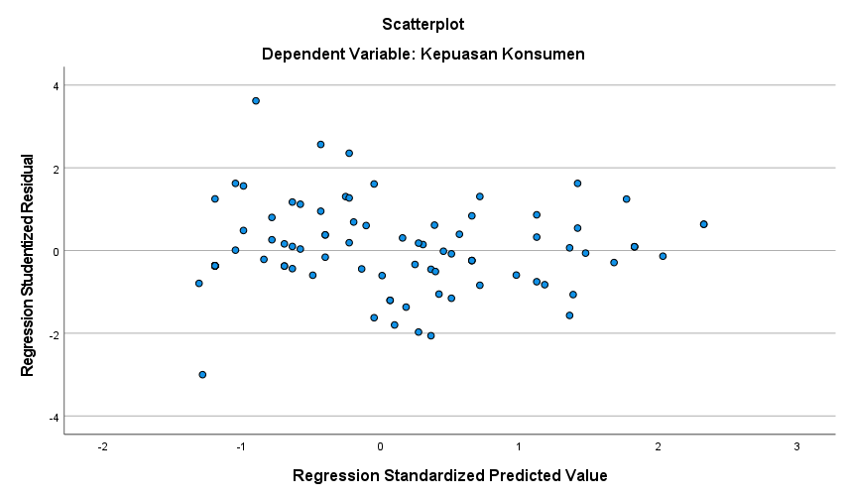

Figure 2. Heteroscedasticity Test
Source : SPSS V.27 Data Processing Results
Based on figure 2 above, it can be seen that the points are distributed randomly and the distribution is below and above the number 0 on the Y axis. This result can be concluded that heteroscedasticity does not occur in the regression model in this study.
- Multiple Linear Regression Analysis
This method is used to predict how the condition (fluctuations) of the dependent variable will be, if two or more dependent variables as predictor factors are manipulated (increased or decreased in value).

Table 7. multiple linear regression analysis
Coefficientsª
Model |  | Unstandardized Coefficients |  | Standardized Coefficients | t | Sig.
 |  | B | Std. Error | Beta | t | Sig.
1 | (Constant) | 8.021 | 2.985 |  | 2.687 | .009
1 | Product Quality | .300 | .091 | .340 | 3.298 | .001
1 | Service Quality | .417 | .095 | .453 | 4.396 | .000
a. Dependent Variable: Kepuasan pelanggan
Source : SPSS V.27 Data Processing Results
Y = b0 + b1X1 + b2X2 + e
Y = 8,021 + 0,300X₁ + 0,417X₂
Based on the results shown in the table above, it can be observed that for the t-value obtained in the appendix:
- Based on the results of the equation test, a constant value of 8.021 was obtained. This value indicates that if the constant value is increased by one unit, it will have a positive impact on employee performance by 8.021.
- The regression coefficient value of b1X1 is 0.300, indicating that an increase in the product quality variable (X1) can increase the customer satisfaction variable (Y) by 0.300. This regression coefficient value indicates that the product quality variable has an impact on customer satisfaction by 0.300.
- The regression coefficient value of b2X2 is 0.417, indicating that an increase in the service quality variable (X2) can increase the customer satisfaction variable (Y) by 0.417. This regression coefficient value indicates that the service quality variable has an impact on customer satisfaction by 0.417.
- Hypothesis Testing
- Partial test (t test)
Table 8. T Test
Coefficientsª
Model |  | Unstandardized Coefficients |  | Standardized Coefficients | t | Sig.
 |  | B | Std. Error | Beta | t | Sig.
1 | (Constant) | 8.021 | 2.985 |  | 2.687 | .009
1 | Kualitas Produk | .300 | .091 | .340 | 3.298 | .001
1 | Kualitas Layanan | .417 | .095 | .453 | 4.396 | .000
a. Dependent Variable: Kepuasan pelanggan
Source : SPSS V.27 Data Processing Results
Based on the table above, the following is a description of the results obtained as follows.
  - For the variable (X1) product quality, the calculated t value is 3.298, which is greater than the table t value of 0.202 (3.298 > 0.202), with a significance level of 0.001, meaning that H1 is accepted. Therefore, the first hypothesis is supported, indicating that product quality has an impact on customer satisfaction at PDAM Tirta Jeneberang in Gowa Regency.
  - For the variable (X2) service quality, the calculated t value is 4.396, which is greater than the table t value of 0.202 (4.396 > 0.202), with a significance level of 0.000, meaning that H2 is accepted. Therefore, the second hypothesis of this study is supported, indicating that there is a positive and significant impact of service quality on customer satisfaction at PDAM Tirta Jeneberang in Gowa Regency.
- Simultaneous Testing (F test)
Table 9. Simultaneous Testing (F test)
ANOVAª
Model |  | Sum of Squares | df | Mean Square | F | Sig.
1 | Regression | 385.172 | 2 | 192.586 | 54.466 | .000^{b}
1 | Residual | 321.764 | 91 | 3.536
1 | Total | 706.936 | 93
a. Dependent Variable: Kepuasan pelanggan
b. Predictors: (Constant), Kualitas Layanan, Kualitas Produk
Source : SPSS V.27 Data Processing Results
Based on the table above, the calculated F value is 54.466 with a significance level of 0.000. This result indicates that the independent variables, namely product quality and service quality, have a simultaneous (joint) effect on the dependent variable, customer satisfaction. The calculated F value is greater than the table F value (54.466 > 0.202), and the significance level is less than 0.05 (0.000 < 0.05).

- Coefficient of determination test (R2)
Table 10. Coefficient of determination test (R2)
Model Summary
Model | R | R Square | Adjusted R Square | Std. Error of the Estimate
1 | .738ª | .545 | .535 | 1.88039
a. Predictors: (Constant), Kualitas Layanan, Kualitas Produk
Source : SPSS V.27 Data Processing Results
Based on the table above, the R² test result is 0.545 (54.5%). This result can be concluded that the extent of customer satisfaction is influenced by the variables of product quality and service quality by 54.5%, while the remaining 45.5% (1 - 54.5%) is influenced by other variables not examined in this study.

CONCLUSION

Based on the research results and the previous discussion, it can be concluded that:
- For product quality as variable (X1) with respect to customer satisfaction as variable (Y), the calculated t value is greater than the table t value, with a value of 3.298 > 0.202, and the significance level is 0.001, which is less than the alpha level of 0.05 (0.001 < 0.05). This indicates that variable (X1) has a positive and significant effect on variable (Y) at PDAM Tirta Jeneberang in Gowa Regency. The results suggest that good product quality can provide satisfaction to customers using the product.
- For service quality as variable (X2) with respect to variable (Y), the calculated t value is greater than the table t value, with a value of 4.396 > 0.202, and the significance level is 0.000, which is less than the alpha level of 0.05 (0.000 < 0.05). This indicates that variable (X2) has a positive and significant effect on variable (Y) at PDAM Tirta Jeneberang in Gowa Regency. The results suggest that if the company provides good service quality to customers, it will result in customer satisfaction due to the high-quality service provided.

REFERENCES

Cahya, M.R.D, Samsudin, A., & Komariah, K. (2020). Kekuatan Servicescape dan Kualitas Pelayanan terhadap Kepuasan pelanggan. Journal of Management and Bussines (JOMB), 2(2). https://doi.org/10.31539/jomb.v2i2.637.
Daryanto & Setyobudi.I ., (2014). Konsumen dan Layanan Prima.Malang : Gaya Media.
Faradina, A. (2016). Pengaruh Promosi dan Kualitas Pelayanan Terhadap Kepuasan Pelanggan pada Rumah Cantik Almanda. Jurnal Ilmu Dan Riset Manajemen, 5(7), 1– 18.
Gitosudarmo. I., (2017), Manajemen Pemasaran, Yogyakarta, BPFE Yogyakarta.
Herlambang, A. S., & Komara, E. (2021). Pengaruh Kualitas Produk, Kualitas Pelayanan, Dan Kualitas Promosi Terhadap Kepuasan Pelanggan (Studi kasus pada Starbucks Coffee Reserve Plaza Senayan). Jurnal Ekonomi, Manajemen Dan Perbankan, 7(2), 56–64. https://doi.org/10.35384/jemp.v7i2.255.
Heryana, I. P. A., Aprinica, N. P. I., & Wardana, M. A. (2023). Pengaruh Kualitas Pelayanan Dan Produk Terhadap Kepuasan pelanggan Di The Rice Table Indonesian Restaurant Desamuda Villas Seminyak Bali. 02(1), 176–201. https://doi.org/dx.doi.org/10.22334/paris.v2i1
Hilaliyah, S. A. (2017). PENGARUH KUALITAS LAYANAN DAN KUALITAS PRODUK YANG DI MODERASI OLEH SUASANA TERHADAP KEPUASAN PELANGGAN. Jurnal Bisnis Dan Manajemen, 4(2), 172–187. https://doi.org/10.26905/jbm.v4i2.1699.
Ibrahim, M., & Thawil, S. M. (2018). Pengaruh Kualitas Produk Dan Kualitas Pelayanan Terhadap Kepuasan Pelanggan Mobile Broadband Di Kota Palembang. Jurnal Keuangan Dan Bisnis, 16(1), 43. Https://Doi.Org/10.32524/Jkb.V16i1.364.
Indrasari, M. (2019). Pemasaran dan Kepuasan Pelanggan. Surabaya: Unitomo Press.
Kotler, P., & Amstrong, G., (2016). Principles of Marketing. Pearson. United States of America.
Kotler, P. & Keller, K. L. (2016) Marketing Management. 15 th Global Edition: Pearson Education Limited, Edinburgh Gate.
Herlambang, A. S., & Komara, E. (2021). Pengaruh Kualitas Produk, Kualitas Pelayanan, Dan Kualitas Promosi Terhadap Kepuasan Pelanggan (Studi kasus pada Starbucks Coffee Reserve Plaza Senayan). Jurnal Ekonomi, Manajemen Dan Perbankan, 7(2), 56–64. https://doi.org/10.35384/jemp.v7i2.255.
Heryana, I. P. A., Aprinica, N. P. I., & Wardana, M. A. (2023). Pengaruh Kualitas Pelayanan Dan Produk Terhadap Kepuasan pelanggan Di The Rice Table Indonesian Restaurant Desamuda Villas Seminyak Bali. 02(1), 176–201. https://doi.org/dx.doi.org/10.22334/paris.v2i1.
Hilaliyah, S. A. (2017). PENGARUH KUALITAS LAYANAN DAN KUALITAS PRODUK YANG DI MODERASI OLEH SUASANA TERHADAP KEPUASAN PELANGGAN. Jurnal Bisnis Dan Manajemen, 4(2), 172–187. https://doi.org/10.26905/jbm.v4i2.1699
Kusuma, F. A. (2017). Pengaruh Kualitas Pelayanan Jasa, Kualitas Produk, Dan Citra Merek Terhadap Kepuasan Pelanggan Pada PT. Trimas Kemasindo Cikarang. Jurnal Manajemen & Bisnis Kreatif, 3(1), 29–53. http://journal.ubpkarawang.ac.id/index.php/Manajemen/article/view/238.
Laetitia, S. I., Alexandrina, E., & Ardianto, S. F. (2021). Pengaruh Kulaitas Produk dan Kualitas Pelayanan terhadap Kepuasan Pelanggan Tanamera Coffee Pacific Place. Jurnal Ilmiah MEA (Manajemen, Ekonomi, Dan Akuntansi), 5(1), 1699–1721.
Manap. (2016). Revolusi Manajemen Pemasaran. Edisi Pertama. Mitra Wacana Media, Jakarta.
Maulidah, I., Widodo, J., & Zulianto, M. (2019). Pengaruh Kualitas Produk Dan Kualitas Pelayanan Terhadap Kepuasan pelanggan Di Rumah Makan Ayam Goreng Nelongso Jember. JURNAL PENDIDIKAN EKONOMI: Jurnal Ilmiah Ilmu Pendidikan, Ilmu Ekonomi Dan Ilmu Sosial, 13(1), 26–29. https://doi.org/10.19184/jpe.v13i1.10416.
Mentang, J. J. ., Ogi, I. W. ., & Samadi, R. L. (2021). Pengaruh Kualitas Produk Dan Kualitas Pelayanan Terhadap Kepuasan pelanggan Pada Rumah Makan Marina Hash In Manado Di Masa Pandemi Covid-19. Jurnal EMBA, 9(4), 680–690.
Novia, A. M., Semmaila, B., & Imaduddin. (2020). Pengaruh Kualitas Layanan Dan Kualitas Produk Terhadap Kepuasan Pelanggan. 7(2), 201–212.
Nurjanah, S., Sukmawati, R., Muslima, M., & Alwi, S. (2021). Pengaruh Kualitas Produk Dan Kualitas Layanan Terhadap Kepuasan Pelanggan Pada Rumah Makan Padang Talago Biru Padasuka. Journal Competency of Business, 5(02), 130–141. https://doi.org/10.47200/jcob.v5i02.1098.
Rangkuti, F. (2016). Teknik membedah kasus bisnis Analisis SWOT. Jakarta: Gramedia.
Satriadi, W., Hendrayani, E., & Siwiyanti, L. Nursaidah. (2021). Manajemen Pemasaran.
Sugiyono. (2018a). Metode Penelitian Kuantitatif, Kualitatif, dan R&D. Alfa Beta.
Sugiyono. (2018b). Metode Penelitian Kuantitatif, Kualitatif, dan R&D. Jakarta: Alfa Beta.
Sundalangi, M., Mandey, S. L., Jorie, R. J. (2014). Kualitas Produk, Daya Tarik Iklan, Dan Potongan Harga Terhadap Minat Beli Konsumen Pada Pizza Hut Manado. Jurnal Riset Ekonomi, Manajemen, Bisnis Dan Akuntansi, 2(1), 313–324. https://doi.org/10.35794/emba.v2i1.3829.
Suryani. (2017). Manajemen Pemasaran Strategik Bank di era Global Menciptakan Nilai Unggul untuk Kepuasan Nasabah. Jakarta: Prenadamedia.
Suwarman, H. R. (2021). Evaluasi Penerapan Evolutionary Algorithm Untuk Pemecahan Traveling Salesman Problem. Sistemik: Jurnal Ilmiah Nasional Bidang Ilmu Teknik, 9(1), 28–34.
Tjiptono, F., & Diana, A. (2018). Pelanggan puas? Tak cukup. Yogyakarta: Andi.
Zahara, M., Andreansyah, N., Relawati, & Sanjaya, V. F. (2021). Pengaruh Kualitas Pelayanan dan Kualitas Konsumen pada Restoran KFC Lampung. Jurnal Ilmu Manajemen Saburai, 7(1), 67--74.
Zebua, Y. (2020). Pengaruh Budaya Kerja Dan Promosi Jabatan Dalam Meningkatkan Kinerja Karyawan Pada Pt. Perkebunan Nusantara Iii Labuhan Haji Labuhanbatu Utara. Ecobisma (Jurnal Ekonomi, Bisnis Dan Manajemen), 7(2), 109–124. https://doi.org/10.36987/ecobi.v7i2.1758.

